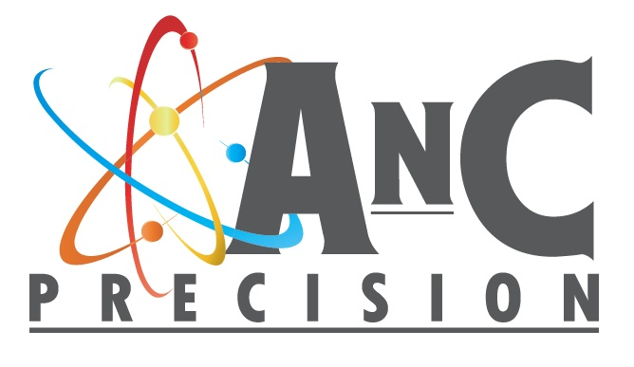
April 25th, 2016
AnC Precision
1119 Sawmill Rd.
Gardnerville, NV 89410
1 (775) 392 3111

Certificate of Test

Tube Tested: Nature’s: XXXXXXXXX Blend Hand Cream (Green)
Tube Diameter: ~40mm
Sealing Machine: AnC Precision Model TS-100
Testing Machine: AnC Precision Model PTS-100 “The Standard”

Abstract

These tubes sealed well in general, with a few outliers that show some deviation in the sealability of the tubes. The tubes are a firm MDPE and many had sidewall bursts above 50 psi indicating the tensile strength of the material and the strengthening properties of the label wrapped around the tube creates a container able to withstand high pressures. The best quality seals were done at 380ºC hot air and zero jaw gap. The jaw gap is important in the sealing process, especially with more rigid materials as in these tubes. With the hot air temperature in the 340ºC range the dwell times in the hot air were much higher. (1.2-1.5 sec range) Many tests produced sidewall bursts on this tube, this is an indication that the seal area has achieved a bond equal to or stronger than the material. The tubes that did not have a sidewall burst all failed higher than 20 psi, which should be high enough by most standards. Although turning up the heat can potentially create a better seal, the appearance quickly deteriorates as the material is softened enough to create “dog ears”. For this reason it is important to strike a balance between seal quality (burst pressures) and exterior cosmetics.
Results

AnC sealed tube burst pressures and settings:
380ºC. 1.05 sec heat dwell/1.25 sec seal dwell. No Jaw Gap (Zero Clearance)

Tube Number | Burst Pressure (PSI) | Side Wall Burst?
1 | 57.72 | Y
2 | 32.77 | N
3 | 58.30 | Y
4 | 58.59 | Y
5 | 44.81 | N
6 | 34.08 | N
7 | 59.61 | Y
8 | 60.19 | Y
9 | 52.06 | N
10 | 24.65 | N
11 | 60.77 | Y
12 | 60.33 | Y
13 | 46.99 | N
14 | 50.76 | N
15 | 53.51 | N
16 | 56.42 | N
17 | 55.69 | N
18 | 23.35 | N
19 | 52.35 | N
20 | 57.72 | Y
21 | 50.03 | N
22 | 42.35 | N
23 | 56.56 | Y
24 | 40.75 | N
25 | 60.77 | Y
Average: | 50.05
Standard Deviation: | 11.21613983

Tested By (AnC Lab Tech) :_______________

Date Tested: ___________________________

Client: ________________________________

Tube Manufacturer: _____________________

